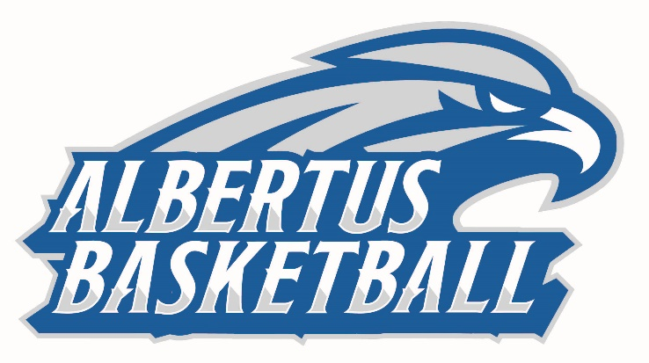
2019-20 ALBERTUS MAGNUS
MEN’S BASKETBALL ROSTER

No. Name Cl. Pos. Ht. Wt. Hometown/High School
01 Isaiah Lewis Jr. G 6-1 180 New Haven, Conn. / Hillhouse
02 Jahmerikah Green-Younger Sr. G 6-1 180 Norwalk, Conn. / Brien McMahon
03 Davon Warner So. G 5-10 170 New Haven, Conn. / Hillhouse
04 Keithantonio Davis Jr. G 6-2 190 Vorhees, NJ / Eastern Regional
05 Terry Dawkins So. F 6-4 220 Bronx, NY / Cardinal Hayes
10 Tyreek Perkins Jr. G 6-2 175 New Haven, Conn. / Putnam Science Academy
12 Qualon Wilkes So. G 5-9 160 Bridgeport, Conn. / Bassick
13 Rob Tindley So. G 5-8 150 Lawnside, N.J. / Haddon Heights
14 Jacqual Gertrude Fr. G 6-3 185 Jersey City, N.J. / Dickinson
15 Andrew Rice So. F 6-4 185 West Haven, Conn. / Hamden Hall
20 Justice Washington Fr. C/F 6-6 240 Hamden, Conn. / Hamden
21 Jack Ryan Fr. G 6-3 175 Stratford, Conn. / Stratford
23 Nigel Carter Jr. G 6-4 195 Dix Hills, N.Y. / St. Anthony
24 Damian Grant Sr. F/C 6-6 200 Waterbury, Conn. / Wilby
30 Jon Delgado Fr. G 5-9 170 Jersey City, N.J. / Hudson Catholic
32 Robby Simmons Fr. G 6-3 185 Hartford, Conn. / Classical High
34 Liam Perryman Sr. C 6-9 210 Poughkeepsie, N.Y. / Poughkeepsie

HEAD COACH: Mitch Oliver - 13th Season
ASSISTANT COACH: Jason Perrier - First Season
VOLUNTEER ASSISTANT COACH: Gabe Sparks - First Season
GRADUATE ASSISTANT COACH: Matthew Tate - Second Season

Pronunciation Guide
02: Juh-mair-ri-kigh
03: Day-von
12: Quay-lon

